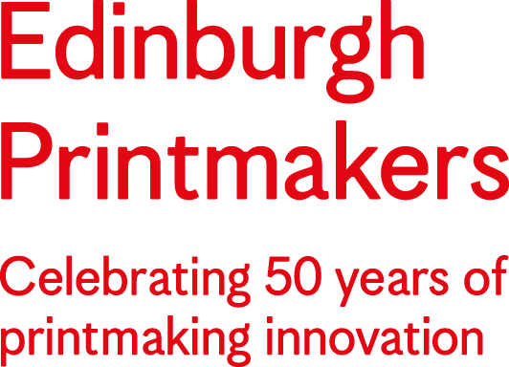

In from the Margins
Residency Opportunity

Application Form

1 Personal Details
Name:
Contact Address:
Daytime telephone:
Mobile:
Email:
Website:

2 Artist Biography
Please provide a short biography of up to 250 words detailing your professional artistic practice and printmaking experience.

3 Motivation
Briefly tell us (up to 100 words per question) about:

What inspires you about printmaking?

Tell us about the printmaking processes that you have experience of, and what you would like to focus on during this residency.

Why are you interested in In from the Margins, and how will this residency benefit you and your practice?

Why do you want to work with Edinburgh Printmakers?

4 What is your preferred period of residency?
Select up to three options, indicating your order of preference [1,2,3]:

 | February 2022 |  | September 2022
 | March 2022 |  | October 2022
 | May 2022 |  | November 2022
 | June 2022 |  | January 2023
 | August 2022

5 Supporting Visual Material:

Please supply up to 6 digital images of previous work and captions. If you are unable to submit work digitally, you can send us your application by post to Edinburgh Printmakers, Castle Mills, 1 Dundee Street, Edinburgh EH3 9FP.

Please Sign and Date Your Application

Print Name: Signed:

Dated:

Please submit this form electronically to Mónica Laiseca at monica.laiseca@edinburghprintmakers.co.uk by 11 AM (GMT) Monday 22nd November 2021.

Alternative Formats
We are open to receiving applications in alternative formats, such as video or audio. If you would like to discuss other application methods, please contact Mónica Laiseca at monica.laiseca@edinburghprintmakers.co.uk or call the Edinburgh Printmakers team on 0131 557 2479 (Tuesday-Sunday, 10am-6pm).

